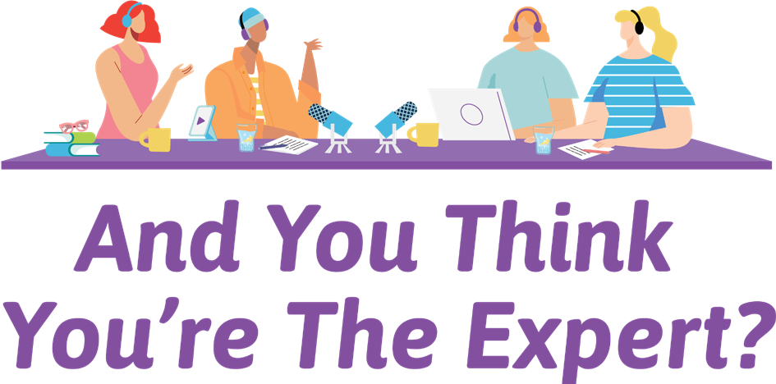

And You Think You’re The Expert?

A publication created by WWILD Sexual Violence Prevention Association Inc.

Acknowledgement of Country
We would like to first and foremost acknowledge the traditional owners of the many unceded lands on which we gathered on for this project; the Turrbul and Jagera people of Meanjin (Brisbane), the Yugambeh people of the Gold Coast, the Gubbi Gubbi people of Caboolture, the Darumbal people of Rockhampton, and the Turrbal, Jagera and Yugambeh people of Logan. We would like
to pay our respects to their Elders past, present and emerging. It always was and always will be Aboriginal land.

And You Think You’re the Expert?
This booklet is an accompaniment to the And You Think You’re the Expert? podcast, created through the Listen Up! Project at WWILD Sexual Violence Prevention Association. This booklet and the podcast reflect the views of 33 women with intellectual disabilities who have experienced violence.

Here’s what they hope you’ll get out of the booklet and podcast:

‘Hopefully learn to listen to us and take what we said and put it into action. I hope they learn it’s not acceptable what they have been doing to us.’

‘I think they will understand more - they will learn more about what it’s like. We are not all the same. People label you, think you are silly and stuff. Listening to
the podcast might help the way people think about people who have a disability.’
‘Maybe people will learn that we have a voice... We are not numbers; we have names, and we are people.’

‘More patience for us. Tolerance.
More of an understanding.
Probably get listened to more, we may even be believed. Belief is a big thing for me. I have been abused my whole life but never believed before now.’

‘I think they will learn to respect us better, show more appreciation for us being here, like being here on earth. I think they will go “hmmm I should be more kind to these people because they are helping me out.” It would be good to get more respect out there.’

Note on wording
Throughout this booklet, you will see us use the wording ‘women with intellectual disability’. We know this is a little controversial. While we are often encouraged to say ‘with a disability’, rather than ‘disabled’, many disabled advocates are advising we use the latter.

However, the women we consulted with were largely not on board with that wording - they preferred ‘with an intellectual disability’. In fact, many of them don’t even like the term ‘intellectual disability’. Women described their disability as ‘a learning disability’, ‘slow learner disability’, ‘brain damage’, ‘a special gift’, and many other terms. The term ‘women with an intellectual disability’ has been used for ease, as it is the most accepted by our participants and the most used by professionals. However, keep in mind the women you work with may not identify with this term. Please follow their lead and use the words they use.

When this booklet and podcast were created, all participants identified as women. However, after completion of the project one of the participants has affirmed their non-binary identity. This is reflected in their expert profile.

In this booklet and in the podcast, we continue to refer to our experts as ‘women’. We recognise that the purpose of this project was to explore gendered-violence as it relates to women and this served
as the framework underpinning all discussions. However, we do not want to conceal the experiences and contributions of our non-binary participant. We acknowledge that violence prevention funding often uses this gendered framework which excludes marginalised genders and their experiences of violence. While we believe the focus on women’s experiences is important, we hope that there are more opportunities in the future to explore the unique experiences of violence for gender diverse people.

Why the Listen up! project?

‘People with a disability are more vulnerable
– if people with a disability felt they were listened to they wouldn’t be so vulnerable. If you are not listened to you get angry or bottle it all up and you don’t say anything. Like I do.’

Women who have an intellectual disability (ID) are grossly over represented as victims of sexual violence, domestic and family violence, and other forms of disability-related violence (such as neglect or abuse from carers; Australian Institute of Health and Welfare, 2020; Disabled People’s Organisations Australia (DPOA), 2019; Healy et al., 2013; Fisher et al., 2016). The high rates of violence they experience can be seen as a manifestation and driver of gender inequality and of ableism.

Women with an ID are:

- often specifically targeted by those who use violence (McCarthy et al., 2019).

- often have difficulty understanding other’s motives which can be exploited by those who use violence (Fisher et al., 2016).

- often reliant on others for personal care (McCarthy et al., 2019). This provides more opportunities for carers who use violence to abuse them (Price-Kelly & Attard, 2010). It also serves as a barrier to escaping violence as they need to arrange alternative ongoing care.

Women with an ID:

- often have a lack of control around living situations, including who they live with and where. Those in group homes are more likely to experience abuse, often from other tenants (Fisher
et al., 2016). They are often reliant on others and systems to move if they need to escape violence (DPOA, 2019).

- are more likely to experience social isolation (Pestka & Wendt, 2014; Fisher et al., 2016). Social isolation can make a person more likely to experience abuse for an array of reasons (Fisher et al., 2016). Women with ID often seek belonging at the expense of experiencing abuse (Pestka & Wendt, 2014). They may not have safe friends or family to ask for help if they need it and this can allow the narrative presented by the person using violence against them to go unchallenged by others.

  - are less likely to have any education around rights, sexual relationships and sexuality (Chrastina & Večeřová, 2018; Byrne, 2018).
If they do receive education about these topics, it if often presented in a way that is inaccessible (Chrastina &
Večeřová, 2018). This means women with ID are often not sure of what to expect in regards to sex and relationships, resulting in people who use violence taking advantage of this lack of knowledge (Chrastina & Večeřová, 2018; Byrne, 2018).

  - are less likely to be able to access support when they experience violence (Robinson et al., 2020; Healy et al., 2013). When they do access services, they are also less likely to experience sufficient support due to services being inaccessible (Robinson et al., 2020; Healy et al., 2013).

The Listen Up! project aimed to do something about this!

We had quite a few lofty goals.

Firstly, we aimed to run some workshops to share rights-based information about sexual violence, domestic and family violence and other forms of disability-related violence.

Secondly, we aimed to create a resource for workers about how they could be more accessible when working alongside women with an ID, who have experienced violence.

‘I’ve got lots of rights – right to be safe, to choose, to feel safe. This was new information. I didn’t know I had rights. I knew I shouldn’t be hit and I had the right to use my own money but I didn’t know anything else.’
So, we brought in the experts: women with an ID! They were the driving force behind the And You Think You’re the Expert? podcast and this accompanying booklet. You will see their nuggets of wisdom throughout.

Lastly, we aimed to challenge some of the assumptions made by workers and community members about women with ID. They are often perceived as ‘less than’ in the community due to negative stereotypes, myths and assumptions.

These beliefs significantly increase the likelihood a person will experience violence, and whether they receive adequate support. We wanted to challenge these ideas and showcase women with ID as leaders, contributors, teachers and experts in this field. They have ideas about what needs to change and are up to the job of making it happen. So, listen up!

Peer Facilitators
Two of our experts were our peer workers, Cassie and Alison.

Here is some feedback from workshop participants about our wonderful peer facilitators:

‘She was cool. Yeah, that was the main reason the group was cool. She was on the same level as us and got us.’

‘I think it is a really good idea, because they [peer workers] understand. Because the other workers don’t have a disability. I think they [peer workers] know what you are going through. This is helpful.’

‘I don’t think I have ever seen someone with an intellectual disability teach. It’s amazing she was brave enough to do it and she didn’t let her intellectual disability stop her. She was just treated normally. I liked that.’

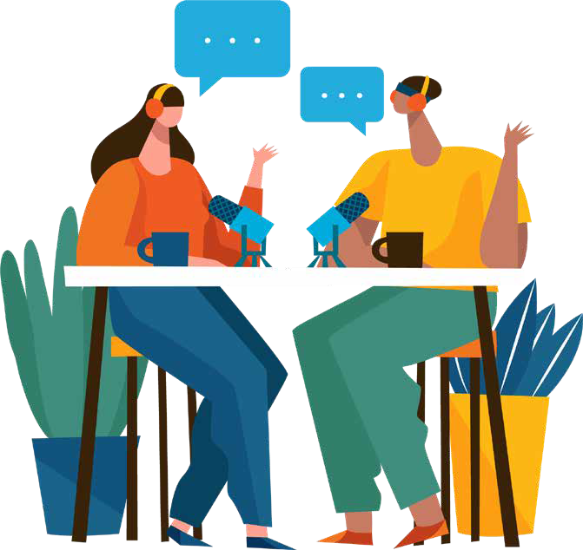

‘Yeah it does help to have someone you know has an intellectual disability – makes it easier to talk about.’

‘It was good for her to get up and have a go. She did well. You guys are doing it the right way – it’s good that you have people with a disability working with people who have a disability.
That way she can interact with us because she understands us probably a bit more than you guys. I think the understanding is a big one. She has a disability so I can relate to her.’

Here’s what Alison and Cassie had to say about being on the project team:
Alison
Qualifications:
32 years’ experience of living with an intellectual disability. Music lover, singer/ songwriter, choir performer, a dog mum, a socialite of the 4101 area and a WWILD peer worker.

Alison: I liked being a part of the project. I enjoyed getting to know the lovely participants and the workers, Jane and
Kaitie. I liked the teaching part best. I liked doing drawing with the participants and the activities, like the one about good and bad relationships.

I think peer workers like me are important as I think I understand the participants more because we have a similar background.

This is a paid job, not a volunteer job. That means a lot to me. I had paid jobs before but this was my major paid job. It helps me get my voice out. It gives me a chance to do day to day life – instead of staying home and doing nothing. I get to go out and about. It’s been amazing working with Jane, Kaitie and Cassie.
What has helped me do my job is having notes, structure, knowing what I am doing in the groups, easy read policies and having rest days. I think other places should have peer workers too.

If you are going to hire a peer worker, you should help them understand words and give them a chance.

I have learnt a lot – like what’s a good and bad relationship, more about podcasts and that Jane makes a good coffee. I have learnt to speak up more if I need help and that I am an amazing listener.

My advice to workers reading this is they should listen to the people who have been through violence more and work on their level.

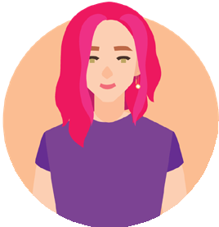

Cassie
Qualifications:
41 years’ experience of an intellectual disability, a mum, a dog mum, a survivor of domestic violence and sexual assault and a WWILD peer worker.

Cassie: I think this project is great. I think there should be more training for workers about how to work with people who have an intellectual disability. My favourite part of this project was having the opportunity to teach workers about this.

Peer workers like me are important. It’s good to have someone who knows what it’s like firsthand. I told Kaitie and
Jane how to make the project better for women with intellectual disabilities. The women in the group loved it, because they knew that someone was there
who had a disability. If there were big words that they didn’t understand, I could explain it in a way they could understand.
Kaitie and Jane making it fun and having notes helped me do my job. I also talked with my partner and my partner’s family about what I needed to do and that helped.

I have learnt to stand up for myself more. I voice how I am feeling. If someone is saying something I don’t agree to, I tell
them what I think. My kids say I am not the mum I was 12 months ago. I am a different person now. I feel happier, not as angry.
It’s helped my mental health having a job.

I know some workers out there think they know more than we know - but they don’t! They don’t know what it’s like to actually have an intellectual disability.

I want workers to know what they say about intellectual disability isn’t always right. I want them to know they are not expert, we are!

Our experts
During our initial consultations, one of the participants said,

‘I think we should be the teachers. We should interview workers on how they work with women who have a disability. We are the experts.’

From this discussion, the podcast idea came to life!

So, without any further ado, we would like to introduce you to the experts!

Our experts

Abbey
Qualifications:
A forgotten Australian, survivor of sexual violence and domestic violence and a mother of 4. Likes to create things for people, is involved with a theatre company, and volunteers at a school helping children.

Amethyst
Qualifications:
Proud Aboriginal and South Sea Islander Woman, artist and domestic violence survivor. Is unique and Autistic. She has 30 years experience of living with intellectual disability.

Ashley
Qualifications:
Survivor of domestic violence and sexual violence, lived experience of having a disability and a mum of 4 boys. Works as a disability/aged care support worker.

Betty Banksia Charlie

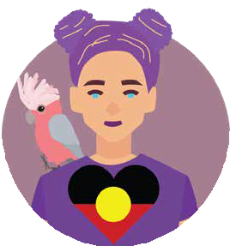
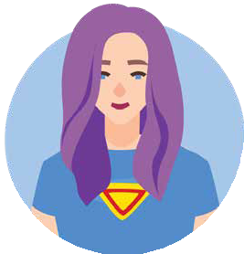
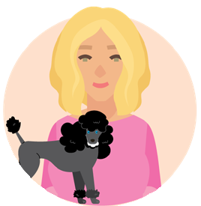
Qualifications:
Over 20 years’ experience supporting carers and other people with a disability, 11 years’ experience of supported accommodation, an avid fundraiser for The Cancer Council and a good listener.
Qualifications:
Proud Grandmother/mother of an awesome child who is trans, protector and Indigenous
non-binary person. Likes driving, cooking and fishing. Wants to change the way society views people who have a disability.
Qualifications:
Lives independently, engaged in the community and nosey. Likes to ask people questions and research systems such
as child safety & police. She is very knowledgeable and a great advocate.

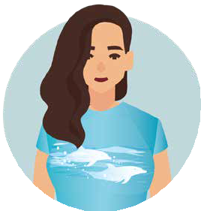
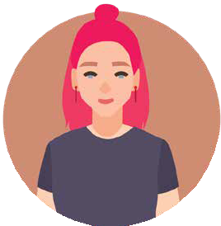
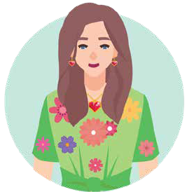
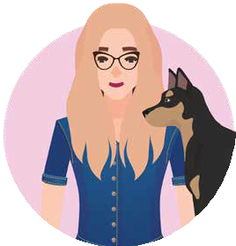
Our experts

Chloe Emma Katie

Qualifications:
Survivor of sexual violence and domestic violence and a
mum of a 24-year-old daughter. She experiences anxiety,
has worked with children and volunteered at the State Emergency service. Enjoys amateur radio and fishing.
Qualifications:
Has 45 years’ experience of an intellectual disability and is a very strong person. Loves
swimming, bowling, spending time with her son and watching ‘Home and Away’.
Qualifications:
WWILD woman for a long time. Likes making bath bombs, and cooking lasagne and quiche.

Louisa Love Linda

Qualifications:
Has 40 years’ experience of an intellectual disability, is a survivor of domestic violence and sexual violence, and
a mum of two boys. Loves bowling, listening to music and playing games on the Wii.
Qualifications:
Has 50 years’ experience of intellectual disability. Likes craft, helping people and giving people presents.
Qualifications:
Has experience of having an intellectual disability and is a survivor of sexual assault. Loves animals and dancing.

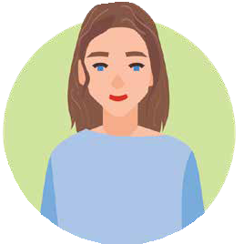
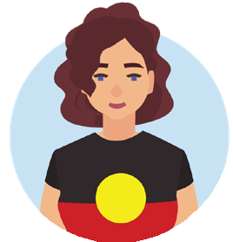
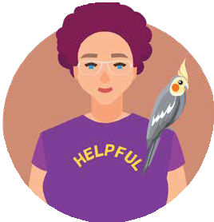
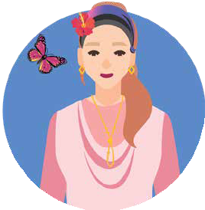
Our experts

Luna
Qualifications:
Advocate for people with a disability, a mummy and a survivor.

Matilda
Qualifications:
Survivor of sexual assault and domestic violence, stay at home mum, Aboriginal woman and an advocate for people who have a disability. Can leg press 195kg, and can lift 60kg above her head.

Milly
Qualifications:
Laundry worker, café worker and has had experiences of violence. Wants the world to be safer.

Minnie Poppy Rose

Qualifications:
Survivor of domestic violence and a mother of 6 children.
Likes making cards, colouring in and helping others.
Qualifications:
People person, hospitality worker (certificate 1,2 and 3), an advocate for people who have a disability and a survivor. Helps WWILD train the police on how to interact with people who have a disability. Likes walking on the beach, doing art and spending time with family.
Qualifications:
Lady with an intellectual disability. Has 3 birds and a dog called Grace. Likes movies, seeing friends and helping people know that sexual abuse isn’t okay.

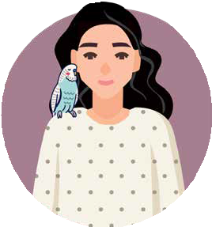
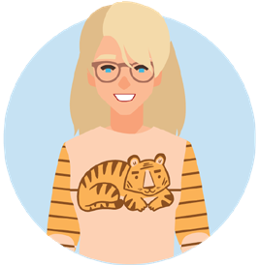
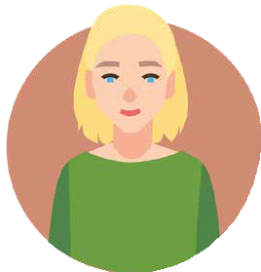
Our experts

Skittles
Qualifications:
Has experience of learning disability and a mother of a cat. Is a worker at WWILD and has volunteered at the RSPCA.
Loves working as it keeps her going. Used to go to the
ladies’ group. Likes cats, birds, helping people and saving sick animals; including possums.

Tiger
Qualifications:
56 years’ experience of an intellectual disability and a mother of 1 child. Has a drivers’ license, is good at driving and good at helping people in a wheelchair get into the car. She likes art.

Zarrafa
Qualifications:
A survivor. Is learning to adjust to mental illness. Likes the wilderness and going for walks.

Star Selena Further experts

Qualifications:
Experience of a learning disability and mental health difficulties. Very independent, a good listener, looks out for other people, makes good choices and is good at sticking up for herself.
Qualifications:
Experience of learning impairment, a mum of three boys and an animal lover.
Enjoys diamond painting, cross stitching, listening to music and being in nature.
8 other experts also helped in various ways, but did not want their picture in the booklet.

Our learners
We had our experts, so we needed to find some people to share their expertise with! Throughout the workshops, participants regularly spoke of several types of workers: support workers, police officers, sexual violence workers, domestic violence workers, support coordinators and mental health workers. So, we asked if we could interview them on the podcast. Kindly, we had the following volunteers from each respective area:

- Stephen Blanchfield, Detective Acting Superintendent from the Queensland Police Service

- Suzie, Sexual Violence Counsellor from Centre Against Sexual Violence, Logan

- Sarah, Domestic Violence Worker from Centre Against Domestic Abuse, Caboolture

- Sam, a Support Worker

- Agnes, a Support Coordinator from Community Living Association

- Diana, Area Manager for Mental Health Workers from Richmond Fellowship Queensland, Transitional Recovery Service

Advice for workers
Our experts had advice for workers about how to be accessible and safe for women with intellectual disability who have experienced
violence. We have divided this information into key themes.

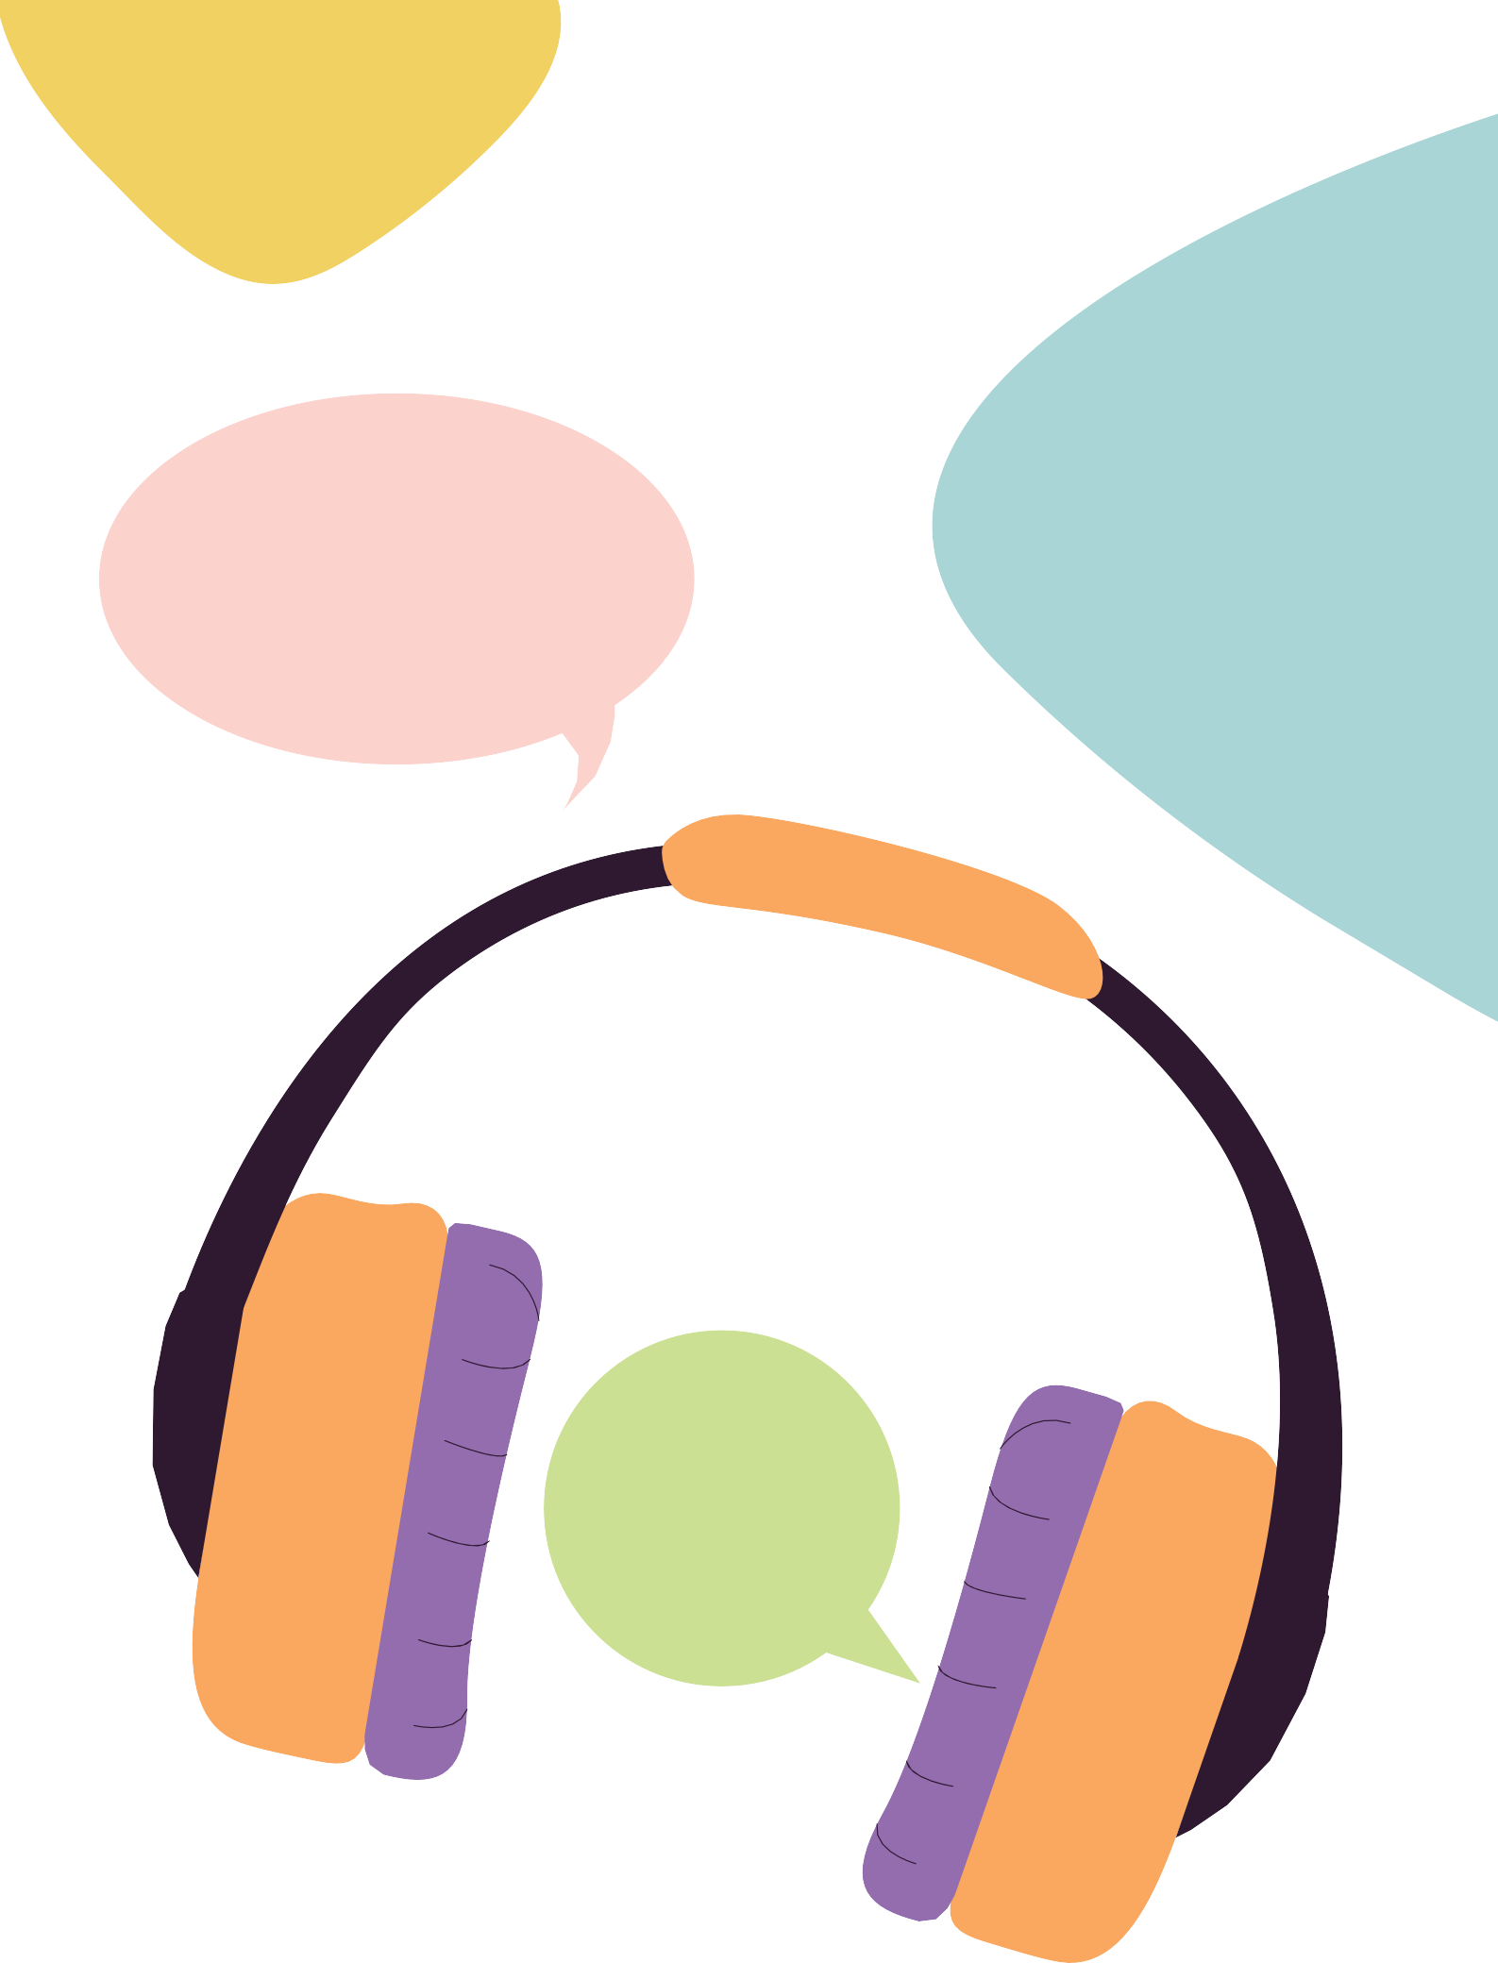
Listen to us

‘Well, you definitely need a lot of patience. Make sure you are listening – that you are really hearing what they are saying.’

‘I have one word: Listen.’

‘Most people don’t listen to us.’

Believe Us

‘You need to believe us, we shouldn’t have to convince you.’
‘I think the worker should always believe the person. Because it is dangerous, if a worker doesn’t believe the person.’

‘We could be telling the truth and they say “well you’re lying about it.” Because what happens if the perpetrator is hurting that person? Not believing them is putting that person at risk. People with intellectual disabilities don’t lie more than anyone else.’

‘Kids with a disability keep things to themselves to keep themselves safe. I faced the problem of reporting an assault that happened to me as a kid. The officer I spoke to, I felt he wasn’t listening, he didn’t care.’

‘People don’t say these things for no reason. I think all workers need to believe and take it seriously. I think people don’t always take it as seriously as they should. People sometimes think that people with a disability make up stories. I believe if someone is telling you they have been sexually abused it has probably happened. It’s real.’

Help us make decisions, don’t make them for us

‘Listen to us, we know what we need.’

‘Some people take over, it’s not teaching you properly, it’s not giving you different avenues to help yourself.’

‘People need to make their own choices; we want to do it for ourselves. I feel like my choices were taken away a million times at the hospital. When this happened, I felt really angry. I feel like I’ve never been given a say at the hospital. My counsellor would explain all the different options and then she would support me to pick an option and then we would go over it together. I feel like sometimes police and mental health workers think we can’t make our own choices, and that’s not right, we can. Sometimes I need help to make a choice. It would be helpful if they gave us some advice first, then we can think about it and decide what to do.’

Rethink your assumptions
‘Make the time to get to know the person. Everyone that has a disability is on a different level. Some people with a disability can function quicker than others. There are lots of different levels and types of disabilities. Everyone shouldn’t be held under the same umbrella.’

‘If we don’t look like we have a disability, people think we don’t have one.’

‘They see someone with a walker or a cane and they understand that more.’

‘I don’t think people with a disability make things up more than others who don’t
have a disability.’

‘Don’t think lesser of us because we have an ID, we are not stupid, we just think on a different wavelength to you.’

‘People with disabilities can do things. People make fun of them because they can’t do things and that’s not right in my eyes. People should have things they can understand. People should be more helpful and caring. Some people just don’t care and don’t go out of their way to help them. That’s the way society is.’

‘I hope that people with a disability can find their way. I would like services to treat us the same as everyone else; just change the way you explain things. I think this would help feel like we belong.’

‘People with intellectual disabilities can have healthy sexual relationships. People with intellectual disabilities are made
to feel like they are not normal human beings. Being a normal human being means having sex if you want to.’
‘I have an intellectual disability but I do my own banking. My sister has power of attorney but I do most of it. Most of the time I make my own decisions.’

Don’t put us in the

too hard basket

‘People do this to people who have an intellectual disability. They think we are too hard or too difficult to work with. I feel like this all the time with mental health workers. Just listen to us, stand by us.’

‘They knock you back and knock you back and knock you back.’

‘I feel like workers just say that they can’t help us, I feel like they are just throwing us away.’

‘I felt like I was put in the too hard basket. I have had that all my life. My mental health went unworked with, because the hospitals kept disrespecting my disability, saying I was misbehaving, seeking attention and being disobedient. They were treating me like a child. They just locked me up. They always focus on the disability and shame me because of it. I tried to explain what was going on but I couldn’t explain it. So, I would get really upset. And they would just
call me disobedient. It’s not like we are trying to be this way, we just don’t know how to word it.’

24 And You Think You’re The Expert?

‘Some workers look at people with intellectual disabilities, as “here we go again we have another problem.”’

‘I’ve got a disability; I am not trying to be difficult.’

‘I don’t want to be singled out [from mainstream services].’

‘I feel like the help I want is never there. Because people find it hard to understand my situation. People say that they understand, when I really don’t think that they do.’

Use easy language & check you’re making sense

‘Never pretend you understand the client if you don’t. That’s a big no no. Keep asking questions.’

‘Staff need to check for understanding, be easy to understand, use different tools, speak to you like an adult, use easy English, have patience.’

‘Some people with a disability might pretend they understand, so it’s important to double check. The person might be a bit embarrassed to say they don’t understand. This is what I was like in the past.’

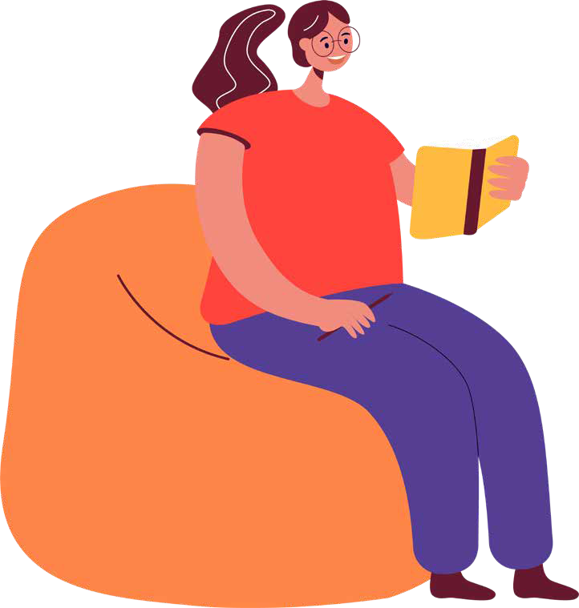

‘It’s important to talk to people in a way they can understand.’

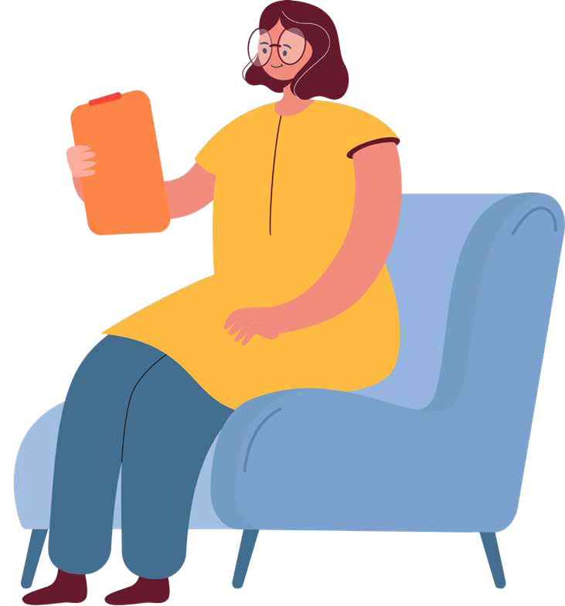
‘You have to keep asking do you understand, or can I simplify this in a way that you will understand better. You could ask them to say what you said back to you in their own words, to make sure they understand. Some people find it hard to say they don’t understand, so it is important to work on the relationship so the person feels comfortable. I can tell workers I don’t understand something if I feel like I know them.’

‘It’s good for workers to make sure they say it’s okay to ask questions. Because if they don’t ask questions they won’t learn.’

‘...we will shut down if people talk to us like a child, or if you talk to us like a professor. I think workers
should ask us some questions at the start around how we communicate. Like ‘what is your level of communication? How do you go with big words?’. Then you are making people feel comfortable before you get into the nitty gritty hard stuff.’

‘Don’t speak to us like a doctor, but don’t speak to us like a child either.’

‘I think workers should definitely check the person understands; after they explain something, if the person has a puzzled look on their face, ask us if we understand. But it’s important to not talk down to us. I don’t like that. Everybody’s understanding is different, the worker should be asking the person what’s the best way for them to understand things.’

‘I think you should talk in a way that we understand – but not in a way that’s
degrading. Don’t talk down to us. Talk to us like a normal person. We are normal people, but you might need to explain yourself in a different way.’

‘Accessing the internet is really hard for people. Some people might not know how to do it. Or they might be too scared. I think there is too much writing on websites. I think there should be some easy English on the website. There should be easy words so people can understand.
Keeping it a normal font is also really helpful. People might get confused if it’s in a different font. It needs to be clear.’

With consent, share what you know with other workers

‘I find it really great when everyone talks to each other. When I had my rails done in my house, they organised everything, they spoke to the OT. I didn’t have to do it. They talked to mum and dad about it. My support coordinator organised it all. If they didn’t do that, my plan wouldn’t work. It would be really hard if I had to do it myself.’

‘Some people have problems with memory. I found that workers working together worked for me because if I could not understand something from one worker, I could ask the other worker and everyone knew the same things.’

Take your time

‘Taking your time with people is really important. Take it step by step. Otherwise, people might not absorb information, it just goes in one ear and out the other.
Some people can only hold so much information; it gets hard for people if they are holding too much information.’

‘I like it when workers make sure they give you the time that you need.’
‘People who have an intellectual disability might need a bit longer for appointments. But it depends on the person. I think you should be able to have counselling for as long as needed.’

'People who have been hurt by someone find it really hard to trust, they shut down and they can’t talk. If this happens, it’s good to let people have a breather in the session. So, they can breathe and take it all in. People need to take a break sometimes so they can absorb what the person has said.’

‘It takes longer to take things in – need to be patient.’

‘I learn to trust workers when they show that they will take their time.’
‘I trust workers who give me time to get to know them. I trust workers who work at my pace. So, if I say, “I don’t really want that help right now”, they understand. I think this is respectful. It’s hard to build trust, because I don’t think people always have a good idea about what trust means and how you get it. I think trust means feeling safe with the person. You can’t just hand out trust, the person needs to earn it. It’s all about earning the trust.’

‘Sometimes I find it hard to find the words. Sometimes the words are lost in my head. I think the worker could give you a moment to have a break before you talk again. It might help the person feel safe if they have a stress ball, or something to muck around with in their hands. Then it would take their mind off what is happening in their head and they can say what they want to say. It works as a distraction.’

‘Sometimes when I try to get something out, I feel like I can go around in circles. It happens a fair bit. I can clam up. Because I don’t know what to expect. If they notice that I am trying to say something, and I am stuck, a worker could help me by checking in around what they think I am trying to say. They shouldn’t just assume. They should check their understanding. It depends on the relationship though. I would feel comfortable to tell a worker that they got it wrong, but it would depend on how safe the person felt in
the relationship. I went to try and get help from a service once. They didn’t understand what I was trying to say, so I didn’t get any help.’

Meet in person and have a cup of tea with us

‘It is better if you do talk in person. I find it better to talk in person myself. Because you have eye contact with them. You can always tell their body language. Well, with your eye contact, you can see if they are listening, if they are interested. Body language tells you a lot –whether you’re bored or not. Another thing I have been thinking about – people do judge you. They don’t say it to your face but they judge you behind your back.
When you’re talking to people, you have this in the back of your mind always. I have had quite a few times – people judging me because of my disability. In person, their body language gives them away. You can’t see through a phone. Meeting in person makes you feel safer.’

‘If the person is meeting the counsellor at the service, they should help them figure out how they should get there. If the person doesn’t know where to go, the worker should help them. If they can’t get there you could offer them different options, if they are still finding it hard the worker should go get them. But pick them up from a safe place. And then explain to them when you see them what they should do next time. I think it is easier to explain things face to face.’

‘I feel disgusted when someone won’t sit down and have a cup of tea, I think “what are they hiding?” It’s important as it helps people relax, they think “oh they are here to help me.”’

‘I think it’s important to try to get to know the person. So, asking them some questions like, “how has your day been”, what sort of things they like to do. It helps me feel safe if the worker takes time to get to know me a little. They could make you feel welcome, like have a cup of coffee with you. For me the smell of tea or coffee brings on a safe feeling. It’s like someone telling you it’s safe here and there is nothing to worry about.’

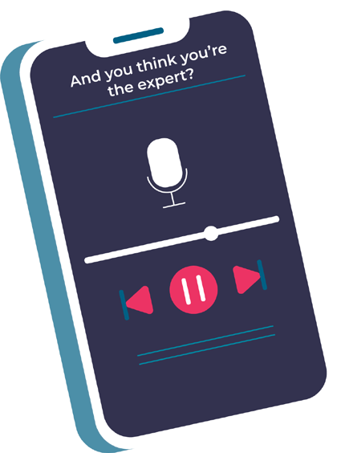
Offer or advocate for a 93a

‘Police officers need to offer this [93a interview] more. If a woman comes in and says I have a disability,
they need to offer one. A support worker should be allowed to come in. They don’t bring it up unless you ask for it. That has been my experience. Police have wanted proof of my disability. This really upset me. I believe this is unfair.’

What’s a 93a interview?
A 93a interview is a reference to The Evidence Act 1977, Section 93a. It is a ‘statement made before proceeding by child or person with an impairment of the mind’. It means that a person with an ID can make a video recorded statement rather than a written one. It is conducted by police officers trained in this particular type of interview. Offering this interview is really important.
The message we received from our guest Stephen Blanchfield, Detective Acting Superintendent from the Queensland Police Service, was that it is best to always offer the 93a interview, even if you have doubts; worse case scenario is that the video statement needs to be transcribed to a written one if it is deemed inappropriate.

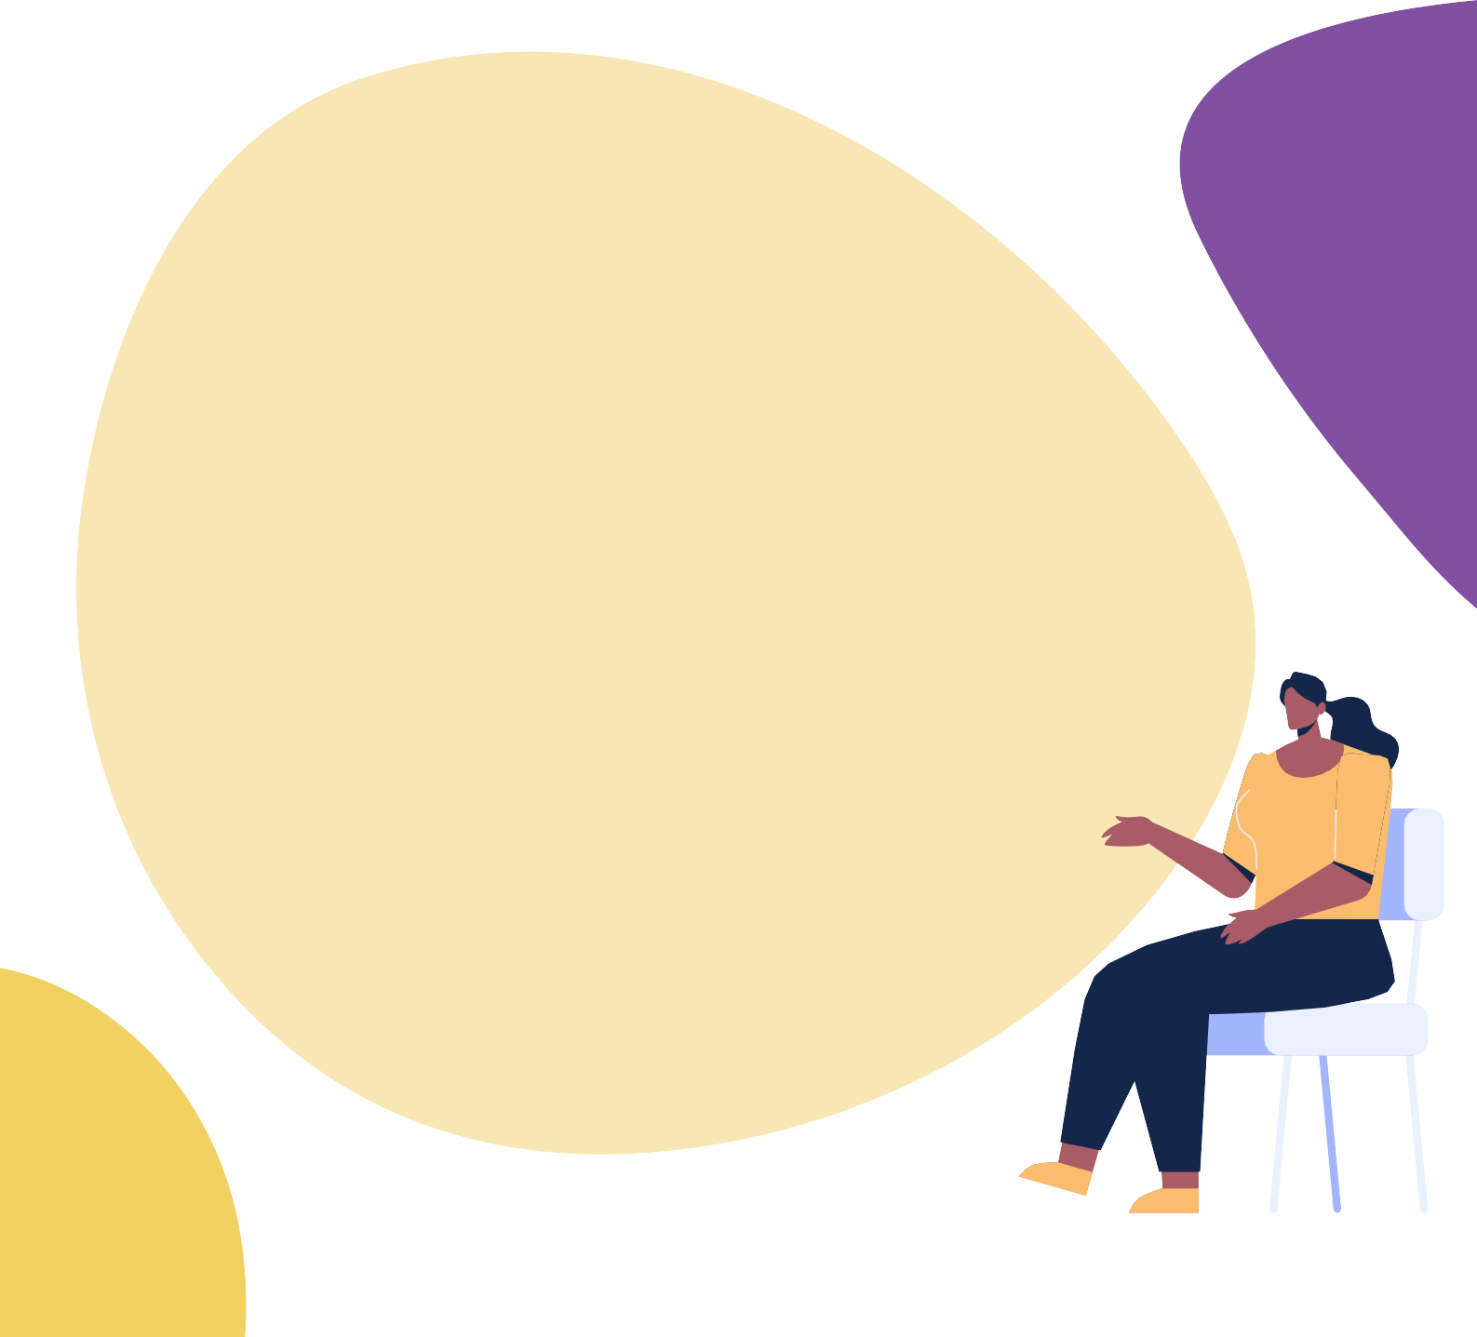
‘Everyone is different. Some people you can see, some have visible intellectual disabilities and some are invisible. Mine is invisible, people don’t always know unless I say I have one. In the groups
we did, some of the people there didn’t know I had an intellectual disability until I said I did. That’s the same for lots of people. Some people with intellectual disabilities will try to hide it because of bad experiences. But letting them know that it’s okay to say that they have an intellectual disability, that they’re not going to be looked down
on. Because that’s how people with intellectual disabilities are seen. We are seen as worthless. It could help if police say why they need to know. Knowing that there is a police officer that deals with people with ID, might help people come out with the fact they have an ID sooner.’

‘Writing statements down might make them feel they’re not valued enough and they aren’t being listened to and understood. Writing it can make them very insecure in
themselves. Because they might not know how to put it in the right words. It’s hard to write down hard things – like emotional things. For people with intellectual disabilities, it’s making them re-live it. I think it’s important police give the option for the interview. 9 times out of 10 people with ID don’t know that’s available. I didn’t even know before the groups and people in the groups telling me. I was like ‘what is that?’. I have always had mine written up by the police. It would have been better for me to do this instead. I wish they had offered it.’

And You Think You’re The Expert? 35

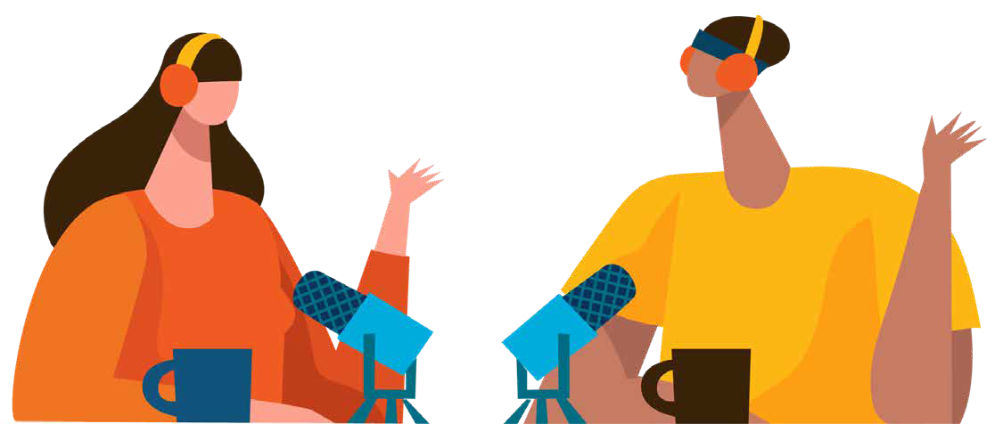
Get training about disability

and violence

‘I have cancelled so many workers because they are not trained properly and know nothing about intellectual disability. They need to be patient, not bossy – know more about the person’s disability. Don’t make assumptions.
Sometimes people need space to think – give them space. They need to open it up to the client, do what they want to do. They need patience.’

‘If they get trained by someone who doesn’t have an intellectual disability, they don’t know how to relate that back to people with intellectual disability. Lots of people just get trained by textbooks and stats and that’s not enough. I have worked with services who didn’t know how to relate to me, but said they were trained. That’s kind of why we are doing this podcast.’

Advice for specific workers
Here’s our experts’ advice for:

- Sexual Violence Workers
- Domestic Violence Workers
- Support Workers
- Support Coordinators
- Mental Health Workers
- Police

Sexual Violence Workers
- Help us get to you - sometimes we need help working out public transport or a taxi.
- Support us to go to court if we want you to.
- Explain the police and court process step by step.
- Use different ways to communicate or different therapeutic tools – for example, diagrams, videos, easy read booklets, pictures, therapy cards, sand tray, drawing and others.
- Provide information about healthy relationships and sex.

‘From my experience with my worker, she literally walked me through the process, the paperwork, and what would happen at court. It was good to have examples. She didn’t use diagrams but that would have been good. Having pictures is good. Seeing a picture of the court room would have been good. What also helped was that I had a good police officer, so if my worker didn’t know, she would ask him. So, the worker asking the police for me was good. They dealt with majority of the stuff for me and only told me what I needed to know. They told me bit by bit. If they had told me all of it at once, it would have been too hard.’

‘Trust is really hard when you have been sexually abused. Really hard. It takes a lot out of you. You have to learn how to re-trust people and learn they are not there to hurt you. Trust is my big thing. It’s also hard when you have an intellectual disability. Once you have been burnt by 3 or more people, every time you start to trust someone the first thing that jumps around your head is “is that person going to hurt me?” So, if you have an intellectual disability and have been sexually abused, its extra hard.’

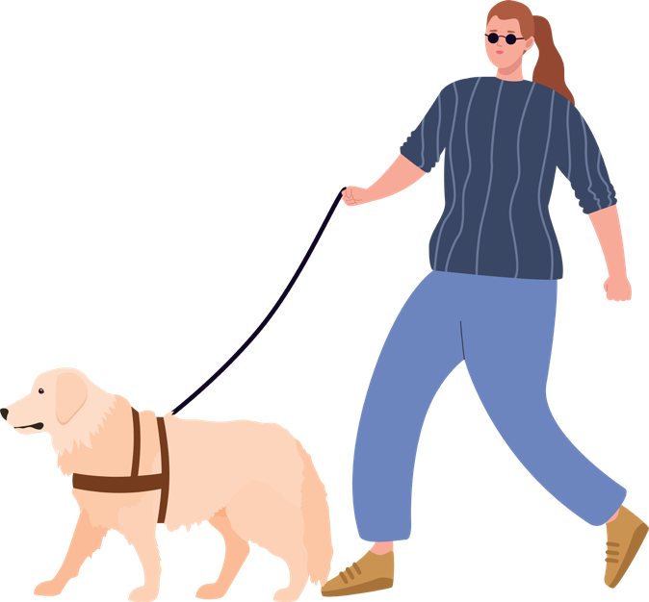
‘It is very hard understanding at court and when you go see the police. It’s too much to take in.
Maybe the worker could show the person videos on Youtube or in writing. Pictures are also great for people who have a disability. The workers should try different ways to help the person understand.’

‘We talk about my dog Luna. She has dogs and we talk about it. She leaves it up to me to talk about things. It just comes naturally. I got to ask her a little about herself and she was quite open with me. We want counsellors to understand
us, but it can be helpful to know a little bit more about the person we are supposed to have this trusting relationship with. I went to a counsellor once and she said “I know what you’re going through.” I asked if it has happened to her and she told me she had read it in a book. I found this disgusting.’

‘I think people with a disability need more places to go to learn about relationships, like what a bad relationship looks like and what a good relationship looks like. This place should be free.’

Domestic Violence Workers
- Make it easy to connect with you – we might not always say the right words or know where to start.
- Help us get to you – sometimes we need help working out public transport or a taxi.
- If we are going to refuge, we might need help working out the steps. Make sure you break it down into small steps, one at a time.
- Make sure you share the safety plan and the risks with our other workers – remembering all this and sharing it is hard work.
- Provide information about healthy relationships and sex.

‘Women with a disability need more education around relationships. If you don’t have any education about relationships, how are you supposed to know when a relationship is bad?’

‘I think it’s easier to talk face to face. But it might be hard for the person to get to the service if they are in a DV relationship.’

‘If they haven’t had the right people around them, if people are abused their whole life, they might think it’s normal.
People need to tell them that you are not being treated right, they might need help to learn what is healthy and what is not.’

‘People with a disability have trouble with public transport, if a worker told me lots of steps of how to get to a safe place, I would have trouble remembering what to do. How would I remember the sequence? They really need to break
it down. For example, be at the train station at such and such time, be on such and such platform, get off the train at the station, which would be say 3 stops from your station. Tell the person to call back if they have trouble and the worker can tell them what to do. When you are leaving you feel really scattered. You need the worker to break down the steps. I was also really scared to travel by myself.’

‘I think they should offer transport... Sometimes it is easier to stay than leave. It might be easier for people if someone could be picked up. People
might have trouble on public transport if they don’t know where they are going.’

‘They shouldn’t do everything on the phone. In person is better to build trust. Perhaps an Aboriginal worker could come out with the worker for the meeting.’

Support workers
- Sit down with us, have a cup of tea and really get to know us. You work in our homes, it’s important we know you well.
- Have a chat with us if you notice signs of abuse or neglect. You saying it’s not okay is important. You may need to learn more about this to notice and be helpful.
- When we tell you about violence, make sure you have a good response. Believe, listen and ask what we want to do.
- Help us to connect with a domestic and family violence or sexual violence support service. We might want help to call them or get to the service.
- We make the decisions. Help us have all the information we need to do this.

‘This is my home not a hospital.’
‘It’s so important to have a good relationship with your support workers... there is trust, you need to trust them... I don’t know how to explain how to get those things but you need them.’

‘We get to choose. We have to be able to choose what we do and can take time to do things.’
‘It’s important for the support worker to believe the client.’

‘I think they should pull them aside and say ‘I am here if you need to talk to me, I am here to listen and to help’... the trust comes in then... if they see a change in their attitude or their mood, they say something inappropriate. It’s important to know your client.’

‘The support worker may have more knowledge than the person with an intellectual disability has and they can explain it simply to the client when the worker isn’t making sense. When I had a worker, she came to an appointment and she understood more than me. So, she broke it down for me. I got it ten times better than when I spoke to the other worker.’

‘They should ask the client how they are going and what is happening for them. They should talk to the client about the signs that they are seeing.’

‘I guess that sitting down, having cups of tea with them, learning about them, about what they like, what they don’t like.’
‘It’s important to have someone you know come along to meetings. At least if the person knows you they can help you answer questions. They can help me communicate to the other person. You should be able to have someone with you whether it is face to face or on the telephone.’

‘For me, I make my own decisions, I am pretty independent. It’s important that this isn’t taken away from me. The staff know that I can make my own choices. For people who need more help, the worker should be giving them choices.’

Support coordinator
- Break down the NDIS plan into easier ideas – sometimes diagrams, pictures, videos, easy read booklets and things like that help.
- Help us to connect with a domestic and family violence or sexual violence support service. We might want help to call them or get to the service.
- Help us find safe accommodation which might mean helping us change our plan (if you can make this quicker with your advocacy, that would be great).
- Share information among our safe supports.
- Help us navigate this confusing system by taking your time to fully explain what you are doing and why.

‘It’s good to repeat it a few times. It took me a bit to understand the NDIS.’

‘Draw it in a diagram. This is how it all works, this is how your money gets spent. If you sat down and said to me this is your plan, you are getting 35,000 dollars, I would have trouble with that. Something visual would
help.’

‘We plan managed it ourselves for a bit and then we got a support coordinator. Then my support coordinator
explained it, she said ‘you have this much for the gym, you have this service’. It was helpful. I wanted to know where my money was going you see.’

‘My support coordinator lets me work it out my way. If she doesn’t think that’s the right way she lets me know. It’s good. She is still okay if I do
it my way. It’s my life and we can’t be pushed around by our support coordinators.’

‘I think the NDIS should implement DV services. So, if your support worker knows you are in DV, they can say that they are worried about you. The support worker could come with a DV worker. Sometimes people need other help then just counselling. Sometimes people can’t just pack up a house and move. There should be amounts in your funding to help with DV. I think DV services need to work with NDIS.’

‘In our group, some of the women said that if they needed to leave supported accommodation because there was violence, it was really hard. They said refuges and stuff were not able
to support. So, they were stuck in violent situations. They use the excuse ‘we don’t have enough funding.’ It’s not okay.
Everyone should be treated the same, whether they have a disability or not. Everyone has the right to be treated the same. Everyone deserves to be safe.’

Mental health workers
- Be really patient – we are not trying to be difficult, we are usually just scared.
- Don’t call an ambulance as a first choice. Sit with us and work out if there is another solution before doing this.
- Help us understand our diagnosis and medication.
- If we need to go to hospital, let staff know about our trauma history and consequent needs (you might need to advocate for us).
- Help us make and understand our emergency plans.

‘It makes me angrier when people just send us to hospital. I’ve had really bad experiences at
hospitals.’

‘Sometimes having a mental illness as well as an intellectual disability makes it harder to understand things. They need to maybe do some research on how to help. It is harder when someone has also experienced violence. Because they might feel scared to talk. So, having all 3 makes it difficult.’

‘Sometimes, it is not that people are trying to be violent, it’s that they can’t communicate and get out what they are trying to say. So, learning to help them communicate is good.’

‘Workers do say this – they do say that you can’t get better. They shouldn’t think that – people think there is no hope. It’s sending a bad message, bad vibes. It makes them think they will never get better, that there’s no cure. I was told I would never overcome what I had to overcome. It made me suicidal. It’s the wrong message. Because there is hope. You might not go back to your
full self but there are people who can help you get to a better area of life and show you what can help you, there’s groups, all sorts of things. There is some light at the end of tunnel. You need to have people believe in you, give you faith, keep encouraging you, saying ‘you are doing much better than you think, look how far you’ve come’. I couldn’t see that when I was unwell.’

Police
- Let us know about the 93a interview before asking if we have an ID.
- Always offer a 93a interview.
- Always explain what you are doing and why – you may need to explain the same thing more than once.
- Always respect the decisions made by us reporting, not our supporters or carers.
- Take out DVO’s for us if we want them, don’t tell us to take out a private application.

‘I have often gone to report things that have happened to me and have felt like I had done the wrong things.’

‘Maybe the police could ask the person are you comfortable telling me about your disability or is there someone we could talk to find out more. Some people don’t like telling people about their disability. If it’s a bit of a two-way conversation it’s easier to open up. If the police officer could make some conversation first that would be helpful. I think people would be more comfortable saying they had a disability if they knew more about the 93a interview. I don’t think people with a disability know this is an option. Some people are not with an organization like WWILD, so they don’t know.’

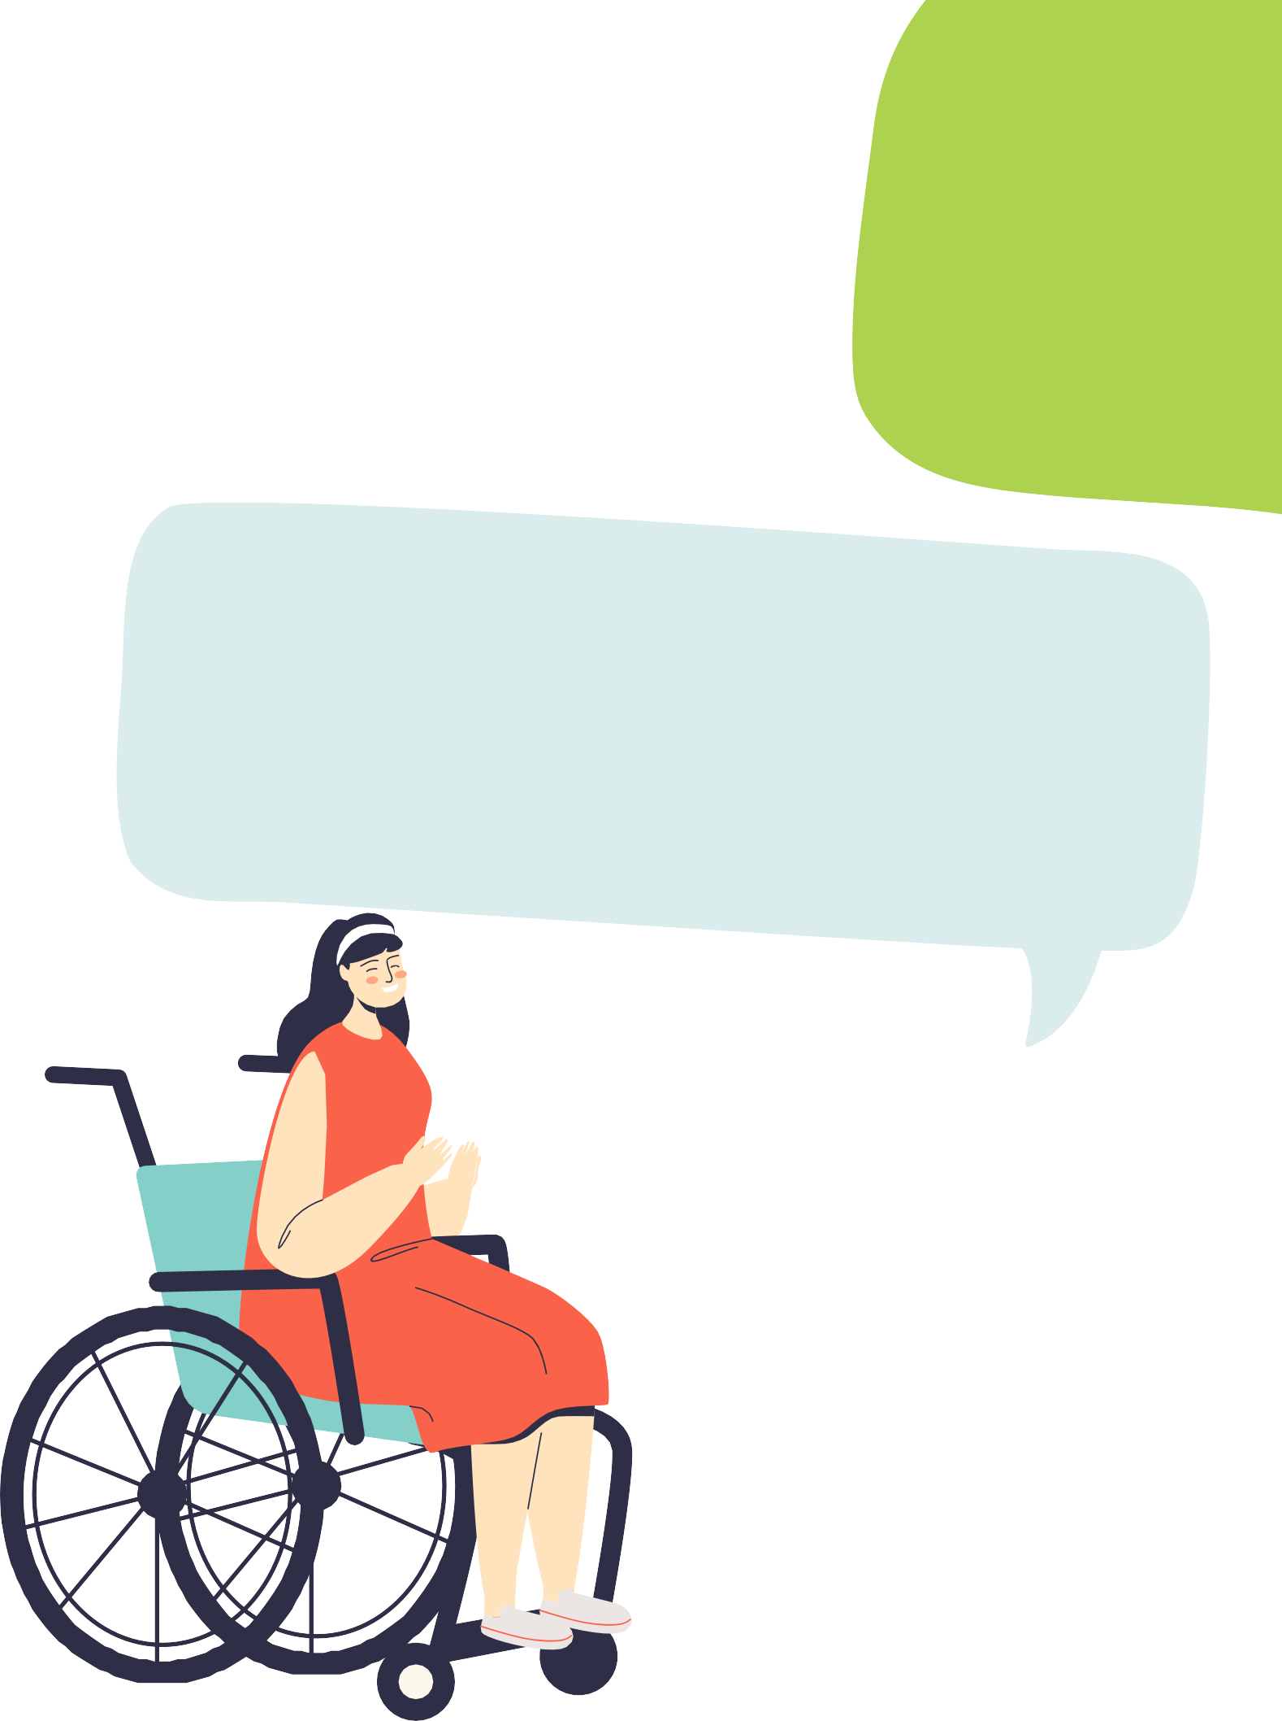
‘I think it’s also important to call the person who has made the complaint to update them, not their support worker; this makes them feel like they can speak up for themselves.’

‘I had a DVO and the police took it out. It was good that the police took it out. It would have been really hard to do by myself. Lots of people with an intellectual disability would find it hard to do themselves. Some of the forms are really hard to understand. Another good part if the police do it, is that you don’t have to come to court. Court can be scary. It is harder when you have an intellectual disability because people with intellectual disability feel like they are not being believed. The judges use difficult words. It’s really confusing.’

‘Not making meetings so formal – make them comfortable. I went to the police and they asked me to wait in a waiting room. In the room there was only a table and two chairs. I wanted to run out of there and not do it. They need to not be so pushy
– the lady I did mine with was just asking the same question - I think she should have given me a break.’

References
Australian Institute of Health and Welfare. (2020). People with disability in Australia 2020. https://www. aihw.gov.au/reports/disability/people-with-disability-in-australia-2020-in-brief
Byrne, G. (2018). Prevalence and psychological sequelae of sexual abuse among individuals with an intellectual disability: A review of the recent literature. SAGE Publications. https://doi.
org/10.1177/1744629517698844
Chrastina, J., & Večeřová, H. (2018). Supporting sexuality in adults with intellectual Disability—A short review. Sexuality and Disability, 38(2), 285-298. https://doi.org/10.1007/s11195-018-9546-8
Disabled People’s Organisations Australia (DPOA). (2019). Violence, Abuse, Exploitation and Neglect Against People with Disability in Australia. https://dpoa.org.au/violence-abuse-exploitation-neglect- people-disability-australia-available-data-march-2019/violence-against-people-with-disability_dpoa_ march-2019/
Fisher, M. H., Baird, J. V., Currey, A. D., Hodapp, R. M. (2016). Victimisation and social vulnerability of adults with intellectual disability: A review of research extending beyond Wilson and Brewer. Australian Psychologist, 51(2), 114–127. https://doi-org.libraryproxy.griffith.edu.au/10.1111/ap.12180
Healey, L., Humphreys, C. & Howe, K. (2013). Inclusive Domestic Violence Standards: Strategies to Improve Interventions for Women With Disabilities?. Violence and Victims, 28(1), 50-68. http://dx.doi.org. libraryproxy.griffith.edu.au/10.1891/0886-6708.28.1.50
McCarthy, M., Bates, C., Triantafyllopoulou, P., Hunt, S., & Milne Skillman, K. (2019). “Put bluntly, they are targeted by the worst creeps society has to offer”: Police and professionals’ views and actions relating to domestic violence and women with intellectual disabilities. Journal of Applied Research in Intellectual Disabilities, 32(1), 71–81. https://doi.org/10.1111/jar.12503
Pestka, K., & Wendt, S. (2014). Belonging: women living with intellectual disabilities and experiences of domestic violence. Disability & Society, 29(7), 1031-1045. https://doi.org/10.1080/09687599.2014.902358
Price-Kelly, S., & Attard, M. (2010). Accommodating Violence: The experience of domestic violence and people with disability living in licensed boarding houses. People With Disability Australia.
Robinson, S., Frawley, P., & Dyson, S. (2020). Access and accessibility in domestic and family violence services for women with disabilities: Widening the lens. Violence Against Women, 27(6-7), 918-936. https://doi.org/10.1177/1077801220909890

The And You Think You’re the Expert? podcast and this accompanying booklet were created as part of the Listen Up! Project, which was kindly funded by the Department of Social Services through the Community Led Projects to Prevent Violence Against Women and their Children

This booklet and its content was developed and published by WWILD SVP ASSOCIATION INC.© in collaboration with 33 women with intellectual disabilities. For more information, see www.wwild.org.au

